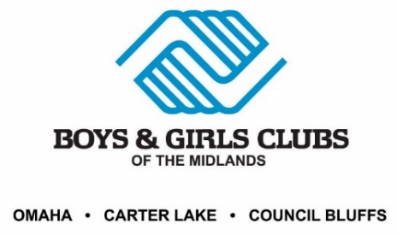
BGCM - Motorized Equipment Policy
It is the policy of the Boys & Girls Clubs of the Midlands that Motorized Equipment is controlled and operated by designated Club staff with restricted key access who have been thoroughly trained in the safe operation of the Motorized Equipment. Designated staff are required to clear the area before operating Motorized Equipment. The area should be clear of all obstructions and people.
Motorized equipment in this policy does not include BGCM vehicles. Please see BGCM Transportation and Traveling with Members Policy for information related to operating BGCM vehicles.
No Club members, visitors, or non-authorized staff or volunteers are permitted to assist with operating Motorized Equipment, nor should they be permitted to be in the vicinity while designated staff operate Motorized Equipment.
Motorized Equipment includes, but is not limited to:
- Motorized room partitions that divide classrooms and program spaces
- Motorized drop-down gates and doors used to secure entrances and exits or to create security barriers between parts of the building
- Motorized gym partitions or gym curtains that divide the gymnasium or basketball court
- Motorized bleachers that come out from the wall
- Motorized basketball hoops
- Lawn mowers, snow blowers, weed trimmers, and similar landscaping tools
- ATV-type vehicles
- Motorized pool covers
- Motorized wheel chair assistance equipment
- Motorized floor cleaners and chariot-style floor finishers
- Boats, canoes, watercraft of any kind
- Commercial mixers, meat slicers, and can openers
- Ovens, stoves, grills, fryers, smokers, steamers/warmers, and dish washers
- Ice machines, sno-cone makers, cotton candy machines
- Pool filter equipment, pool pump room computers
- Heating and AC units
It is each Unit Director’s responsibility to ensure staff that authorized Club staff (and all other authorized users) are adequately trained and to maintain a list of all authorized users of BGCM Motorized Equipment at their unit.

